**PIZZA SALES SQL QUERIES**

**A. KPI’s**

**1. Total Revenue:**

SELECT ROUND(SUM(total_price), 2) AS Total_Revenue

FROM pizza_sales;

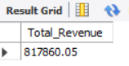

**2. Average Order Value**

SELECT ROUND(SUM(total_price) / COUNT(DISTINCT order_id),2) Avg_Order_Value

FROM pizza_sales;

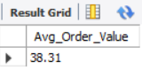

**3. Total Pizzas Sold**

SELECT SUM(quantity) AS Total_Pizzas_Sold

FROM Pizza_sales;

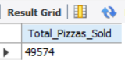

**4. Total Orders**

SELECT COUNT(DISTINCT order_id) AS Total_Orders

FROM pizza_sales;

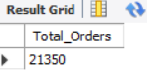

**5. Average Pizzas Per Order**

SELECT ROUND(SUM(quantity) / COUNT(DISTINCT order_id),2) AS Average_Pizza_per_Order

FROM pizza_sales;

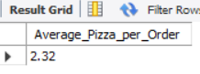

**B. Daily Trend for Total Orders**

SELECT

DAYNAME(STR_TO_DATE(order_date, '%d-%m-%Y')) AS day_name,

COUNT(DISTINCT order_id) AS total_orders

FROM

pizza_sales

GROUP BY day_name;

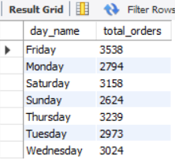

**C. Monthly Trend for Orders**

SELECT

MONTHNAME(STR_TO_DATE(order_date, '%d-%m-%Y')) AS month_name,

COUNT(DISTINCT order_id) AS total_orders

FROM

pizza_sales

GROUP BY month_name;

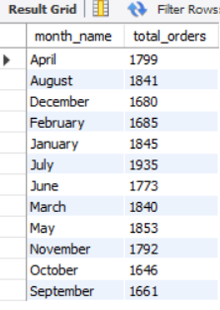

**D. Hourly Trend for Orders**

SELECT HOUR(STR_TO_DATE(order_time, '%H:%i:%s')) AS order_hour,

COUNT(DISTINCT order_id) AS total_orders

FROM pizza_sales

GROUP BY order_hour;

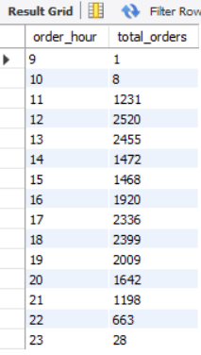

**E. % of Sales by Pizza Category**

SELECT pizza_category, ROUND(SUM(total_price) / (SELECT SUM(total_price) FROM pizza_sales) * 100,2) AS sales_perc

FROM pizza_sales

GROUP BY pizza_category;

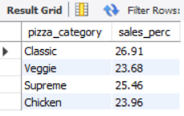

**F. % of Sales by Pizza Size**

SELECT pizza_size,ROUND(SUM(total_price) / (SELECT SUM(total_price) FROM pizza_sales) * 100,2) AS sales_perc

FROM pizza_sales

GROUP BY pizza_size;

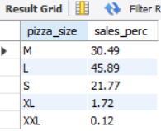

**G. Total Pizzas Sold by Pizza Category**

SELECT pizza_category, SUM(quantity) AS Total_Pizzas

FROM pizza_sales

GROUP BY pizza_category;

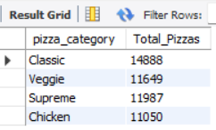

**H. Top 5 Pizzas by Revenue**

SELECT pizza_name, SUM(total_price) AS Total_Revenue

FROM pizza_sales

GROUP BY pizza_name

ORDER BY Total_Revenue DESC

LIMIT 5;

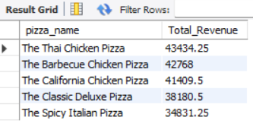

**I. Bottom 5 Pizzas by Revenue**

SELECT pizza_name, SUM(total_price) AS Total_Revenue

FROM pizza_sales

GROUP BY pizza_name

ORDER BY Total_Revenue

LIMIT 5;

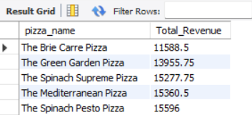

**J. Top 5 Pizzas by Quantity**

SELECT pizza_name, SUM(quantity) AS Total_Quantity

FROM pizza_sales

GROUP BY pizza_name

ORDER BY Total_Quantity DESC

LIMIT 5;

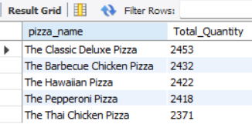

**K. Bottom 5 Pizzas by Quantity**

SELECT pizza_name, SUM(quantity) AS Total_Quantity

FROM pizza_sales

GROUP BY pizza_name

ORDER BY Total_Quantity

LIMIT 5;

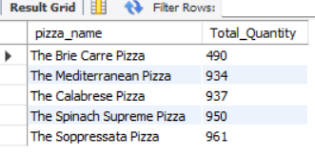

**L. Top 5 Pizzas by Total Orders**

SELECT pizza_name, COUNT(DISTINCT order_id) AS Total_Orders

FROM pizza_sales

GROUP BY pizza_name

ORDER BY Total_Orders DESC

LIMIT 5;

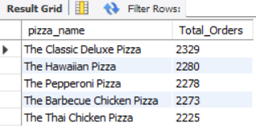

**L. Borrom 5 Pizzas by Total Orders**

SELECT pizza_name, COUNT(DISTINCT order_id) AS Total_Orders

FROM pizza_sales

GROUP BY pizza_name

ORDER BY Total_Orders

LIMIT 5;

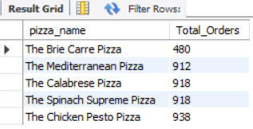

***NOTE***

If you want to apply the pizza_category or pizza_size filters to the above queries you can use WHERE clause. Follow some of below examples

SELECT pizza_name, COUNT(DISTINCT order_id) AS Total_Orders

FROM pizza_sales

WHERE pizza_category = 'Classic'

GROUP BY pizza_name

ORDER BY Total_Orders ASC

LIMIT 5;